# Using the MayoLewisFit low conversion f-F Reactivity Ratio Calculator

By Simon Harrisson

These instructions will cover how to use the MayoLewisFit f-F Reactivity Ratio Calculator. This spreadsheet is designed for use with copolymer composition data obtained at low monomer conversion, such that the change in monomer concentration can be assumed to be negligible, and the Mayo-Lewis equation (1) can be assumed to be valid.

In this equation, *F*1 represents the fraction of monomer 1 in the copolymer, *f*1 the mole fraction of monomer 1 in the monomer feed (f1 = [M1]/([M1] + [M2]), *f*2 = 1-*f*1, and r1 and r2­ are the reactivity ratios of monomers 1 and 2 respectively.[1]

This equation is derived from the terminal copolymerization model, in which the reactivity of the growing polymer chain is assumed to be determined by the final (terminal) monomer unit: the kinetics are assumed to be independent of both the nature of earlier monomer units and the length of the chain.

**1. Data input**

Experimental f1 and F1 data can be entered in cells B10-B60 and C10-C60, respectively. Up to 51 datapoints may be entered. Data can be entered in any order, and it is possible to leave blank rows.

**2. Initial estimate of r1 and r2**

An initial estimate of r1 and r2 is required. These must be greater than zero. In the absence of any prior information about the reactivity of the comonomers, r1 = r2 = 1 would be a reasonable initial guess.

**3. Calculation**

Use the built-in Solver Function (Data --> Solver) to find values of r1 and r2 that minimize the sum of squared residuals (SSR, cell G2)

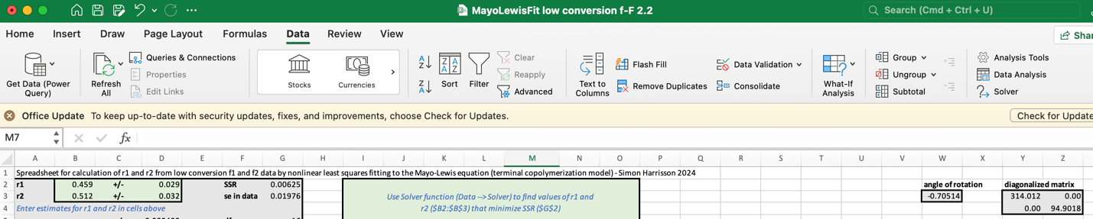

The inputs to the Solver should be set as follows:

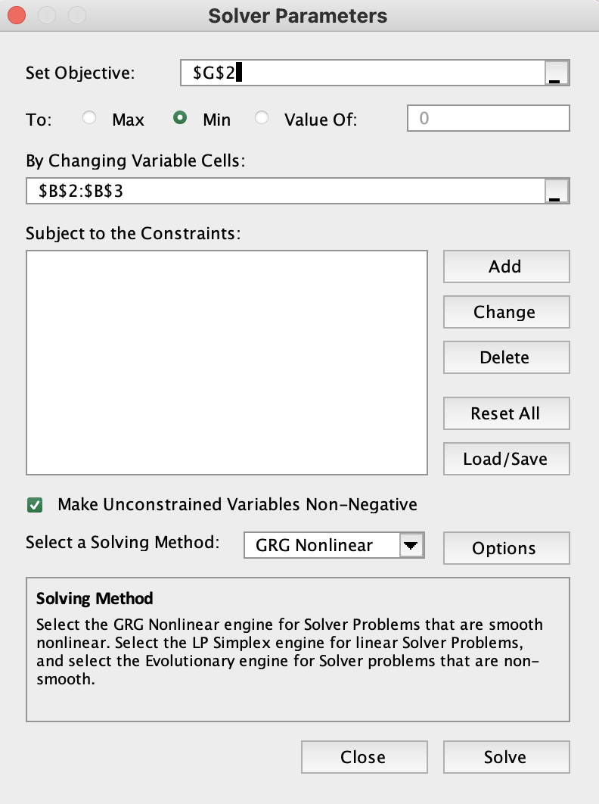

**4. Numeric Output**

The output values of r1 and r2 are shown in cells B2 and B3. The estimated standard errors for these values are shown in cells D2 and D3.

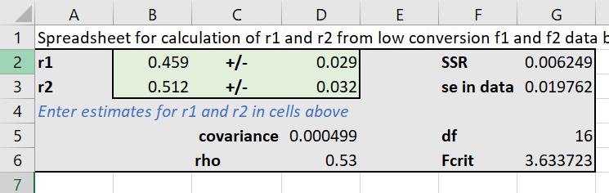

Other outputs include the following:

**Cell G2** : the sum of squared residuals (SSR)

**Cell G3** : the standard error in the data, *s* – this is calculated as √(SSR/df) where df is the number of degrees of freedom.

**Cell D5** : The covariance of r1 and r2

**Cell D6** : Pearson's correlation coefficient (ρ) for r1 and r2. A value of 0 indicates completely independent errors in r1 and r2­, 1 indicates complete correlation.

**Cell G5** : The number of degrees of freedom (equals N-2 where N is the number of data points)

**Cell G6** : The critical *F* value, used to determine the limits of the 95% joint confidence region and 95% confidence band. This is the value of the *F* distribution with 2 and df degrees of freedom, at a probability of 95%.

**5. Graphical Output.**

The spreadsheet also outputs two graphs. The first is a graph of the experimental *F*1 as a function of *f*1 (blue points), with the model (blue line) and a 95% confidence band, representing the 95% confidence interval for *F*1 as a function of *f*1. The data for the model lines and confidence band is found in cells O9:O109 (*f*1), Q9:Q109 (model *F*1), T9:T109 (upper confidence band), and U9:U109 (lower confidence band).

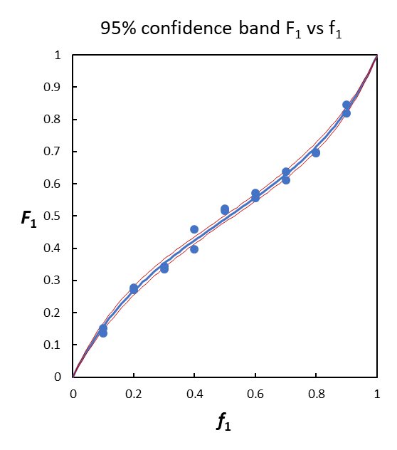 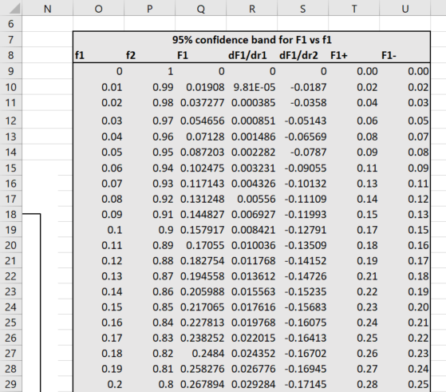

The second is a graph of the point estimate for *r*1 and *r*2 (blue cross) and its 95% joint confidence region (red line). This is a graphical representation of the uncertainty in *r*1 and *r*2. The data for the joint confidence region is found in cells Z9:Z109 and AA9:AA109.

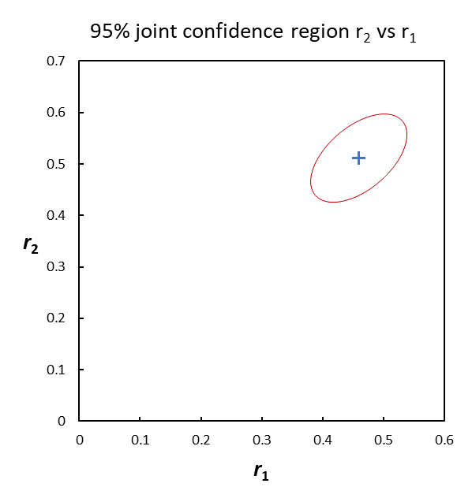 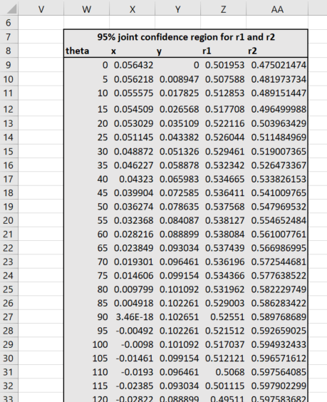

The values of *r*1 and *r*2 contained within the joint confidence region will give model composition curves that are contained within the confidence band of the first graph. These graphs can be copied and modified by the user.

The following data was used to produce these graphs and parameter estimates:

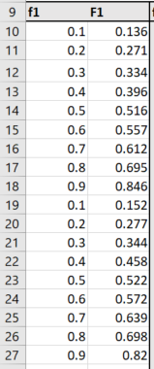

**Troubleshooting**

The spreadsheet may crash if the parameter estimates are too far from the optimal values, particularly when either the initial estimate or the optimal value include values close to zero. If this occurs, retry from a different initial estimate of r1 and r2.

**Acknowledgements**

Helpful discussions with Dominik Konkolewicz, and Alex van Herk and Gregory T Russell of the IUPAC subcommittee on polymerization kinetics and mechanisms.

**Notes**

**Note 1. Error estimation**

For each experimental data point, the parameter estimate (cells B2:B3) is used to generate the model *F*1 (column E), the residual (difference between experimental and model *F*1, column F), and the partial derivatives of *F*1 with respect to *r*1 and *r*2 (columns G and H). These data are used to calculate the matrix **M** (cells J10:K11)

Uncertainties in *r*1 and *r*2 are estimated from the standard error in the data (*s*, cell L2) and the components of **M-1**(cells J13:K14). Thus the error in *r*1 is calculated as the product of *s* and the square root of J13, and the error in *r*2 as the product of *s* and the square root of K14. The covariance is given by *s*2 × K13. Pearson's correlation coefficient is calculated as the ratio of the covariance and the product of the errors in *r*1 and *r*2 (D5/(D2×D3).

**Note 3. Confidence band**

The 95% confidence band is obtained assuming that the Mayo-Lewis function is approximately linear for small changes in *r*1 and *r*2. As such, it will not be valid when errors are large. The confidence band is obtained from equation 5:

In which V(*r*i) represents the estimated variance of *r*i, and cov(*r*1, *r*2) the estimated covariance of *r*1 and *r*2. The estimated variances are the squares of the estimated standard errors in *r*1 and *r*2 (cells D2:D3).

**Note 4. Joint confidence region**

Like the confidence band, the 95% joint confidence region is obtained assuming local linearity of the Mayo-Lewis function. If this condition holds, the joint confidence region of *r*1 and *r*2 will be an ellipse whose axes can be obtained by diagonalizing the matrix **M** and dividing its elements by (2*F*crit × *s*2). The resulting matrix **D** is given in cells Z3:AA4.

This gives an ellipse with the equation

in which *dij* is the element in the *i*th row and *j*th column of **D**.

The values of *x* and *y* that satisfy this equation are given parametrically by

These values are given in columns X and Y, for angles phi ranging from 0°to 360°(column W).

Diagonalization of **M** corresponds to applying a rotation through an angle θ given by equation 8

in which *mij*  is an element of **M**.

Rotating the ellipse through –θ, and translating its center to the point estimates of *r­*1 and *r*2 gives the joint confidence region shown in the graph.

Note that when one or both reactivity ratios are close to zero, physically unrealistic negative values may be included in the joint confidence interval.

For example, the following simulated f1-F1 data was obtained by setting r1 = 0.01 and r2 = 20 and applying a normally distributed error with a standard deviation of 0.01.

|  |  |
| --- | --- |
| ***f*1** | ***F*1** |
| 0.1 | 0.010 |
| 0.2 | 0.008 |
| 0.3 | 0.035 |
| 0.4 | 0.036 |
| 0.5 | 0.035 |
| 0.6 | 0.059 |
| 0.7 | 0.088 |
| 0.8 | 0.153 |
| 0.9 | 0.257 |
| 0.1 | 0.000 |
| 0.2 | 0.012 |
| 0.3 | 0.038 |
| 0.4 | 0.042 |
| 0.5 | 0.049 |
| 0.6 | 0.079 |
| 0.7 | 0.106 |
| 0.8 | 0.149 |
| 0.9 | 0.258 |

Applying the spreadsheet to this data gives the following results:

r1 = 0.009 +/- 0.006

r2 = 19.1 +/- 1.0

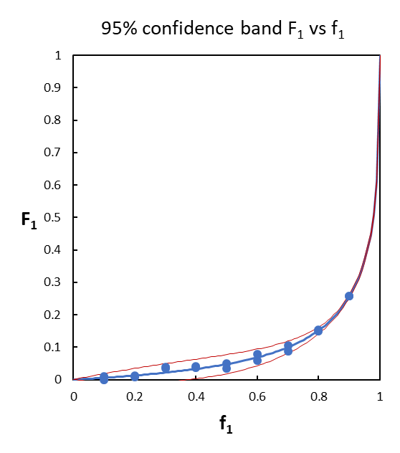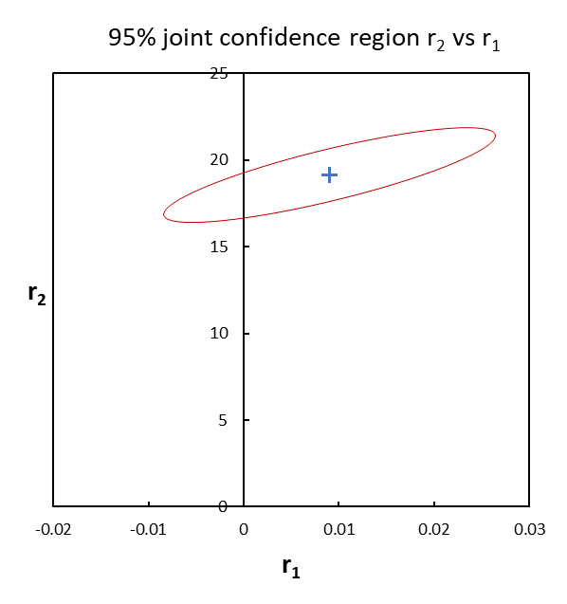

The joint confidence region for r1 and r2 includes physically unrealistic negative values of r1, which should be ignored. Such physically unrealistic values will nevertheless provide a reasonable fit to the experimental data if substituted into the Mayo-Lewis equation.

1. Note that if changes in monomer concentration during the experiment are significant, the integrated form of the Mayo-Lewis equation (the Meyer-Lowry equation, 2) should be used. The CONTOUR program, for example, is a freely-available tool that is designed for this purpose.

   In equation 2, *X* is the total conversion, and *fi*,0 is the initial mole fraction of monomer *i*.