# Using the Konkolewicz Group SEC Deconvolution Macro

By Kevin Burridge and Dominik Konkolewicz

These instructions include some details specific to the Agilent GPC system, but are generalizable to all GPC systems. There are two versions of the peak deconvoluter. One **“Deconvoluter_Template_Retention Time.xlsx”** is based on retention time as the X variable that is input. This assumes you have a column calibration and raw retention time vs RI signal data If using this use **A and C** below. The **“Deconvoluter_Template_MolecularWeight.xlsx”** is based on molecular weight (not logM) as the X variable that is input. This assumes you have a already run basic SEC analysis and have a molecular weight distribution (M vs distribution or RI signal) if using this version go to **B and C** below. Instructions are given below for both systems.

**A. If using the file “Deconvoluter_Template_Retention Time.xlsx”**

1. **Obtain calibration information: slope and y-intercept of calibration curve:**
   1. Go to the MW Results tab of the exported SEC trace you wish to deconvolute.
   2. Scroll to the bottom, find the “coeff a” and “coeff b” cells (see Appendix for a screenshot).
   3. Enter those numbers into the deconvolution spreadsheet. “coeff a” is the intercept, “coeff b” is the slope (cells B1 and B2) (see Appendix for a screenshot).
   4. If the curves for deconvolution are from the same batch of samples, the calibration should be the same for all of them, so you typically only have to do this step once.
2. **Add SEC trace to deconvolution spreadsheet**
   1. Clear the old dataset: select and delete cells **D6:AD6** to bottom. (shortcut: select cell D6 > press ctrl+shift+right > press ctrl+shift+down > press delete.)
   2. Add the new data: go to the Slice Table tab of the SEC trace you wish to deconvolute. Copy the retention time (RT) and refractive index signal (RI) columns.
   3. Paste the whole trace into the deconvolution spreadsheet starting at cell **D2**.
   4. Extend the curve fit equations to the new dataset: select **D5:AD5** and double-click the bottom right corner of the marquee.

**B. If using the file “Deconvoluter_Template_MolecularWeight.xlsx”**

1. **Add the processed molecular weight distribution trace to deconvolution spreadsheet**
   1. Clear the old dataset: select and delete cells **D6:AD6** to bottom. (shortcut: select cell D6 > press ctrl+shift+right > press ctrl+shift+down > press delete.)
   2. Add the new data: go to the Slice Table tab of the SEC trace you wish to deconvolute. Copy the molecular weight (M) and processed distribution (dwdlogM) columns. If a processed distribution is now available the molecular weight (M) and refractive index signal (RI) columns can be used instead.
   3. Paste the whole trace into the deconvolution spreadsheet starting at cell **D2**.
   4. Extend the curve fit equations to the new dataset: select **D5:AD5** and double-click the bottom right corner of the marquee.

**C. For both templates “Deconvoluter_Template_Retention Time.xlsx” and “Deconvoluter_Template_MolecularWeight.xlsx”**

1. **Give the solver a good starting point**
   1. Definitions:
      1. “peak 1 h” – the height (in RI units) of the generated peak 1.
      2. “peak 1 mean” – the center and mode of peak 1’s MW distribution in log units.
      3. “peak 1 st dev” – The standard deviation of peak 1 – the peak width.
      4. “fit” – the sum curve of all the generated peaks.
      5. “chi” – the sum of differences between the “fit” curve and the experimental SEC trace. The solver will minimize this value.
   2. The values from the last dataset are likely to be far off, so enter new values in the peak heights and means (B4:B14) to get a fit that approximates the peak height/shape of the experimental SEC trace. If you expect to see only two peaks, simply enter “0” in the “peak 3 h” cell (B12).
2. **Run the Solver**
   1. If you don’t already have the free Solver add-on for Excel, you can find instructions [here](https://www.solver.com/excel-solver-how-load-or-start-solver)
   2. In the top menu, go to Data > Analyze > Solver.
   3. Set the Objective cell as $B$16 (chi) and change Variable Cells to $B$4:$B$14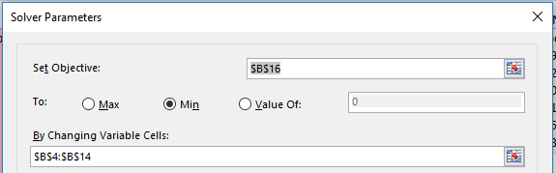
   4. If you want to add constraints, such as limiting the st dev of a peak, you can, although this is not always necessary to obtain a good fit.
   5. Click Solve. If you are satisfied with the fit, you’re done. If not, try manually altering the peak values again, but make the fit look different than you did the first time. It’s a bit of an art, but the solver can approach different values depending on the starting point.
   6. **NOTE. If only deconvoluting 2 peaks set peak 3 h to 0 (I.e. B12=0) and use change Variable Cells to $B$4:$B$10.**
   7. You should obtain deconvoluted peaks. Values of Mn, Mw and dispersity and the relative weight fraction of each peak should be visible in B18-B36 with the appropriate labels as seen below.

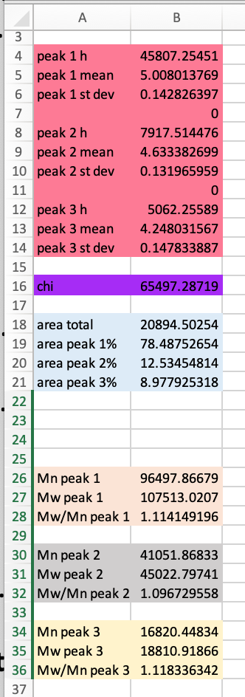

* 1. You can also extract the deconvoluted peaks in columns G, H and I

1. **Reset for the next deconvolution**
   1. If you are running batch deconvolution, it is easiest to save each file by using the “Save As” function, especially if there are annotations or predicted Mn values you wish to match up against the peak fits in each individual file. Once you have done “Save As” you can repeat the process starting from Step 2 for the next deconvolution and “Save As” once the new one is finished.

# Appendix

Location of calibration information in SEC trace.

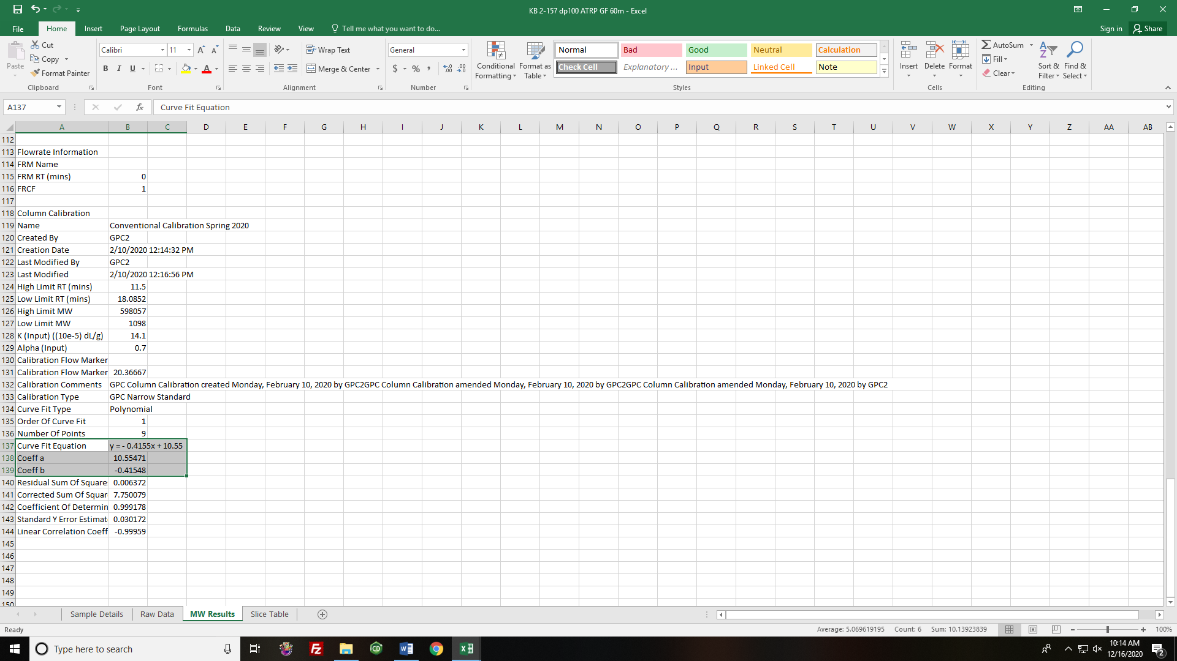

Where to put calibration information in the deconvolution spreadsheet: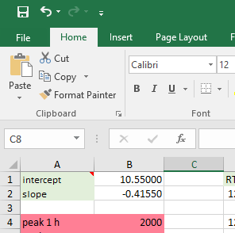

What a good fit should look like:

