Using the Konkolewicz Group Hyperelastic Model ReadMe
By Camaryn Bennett and Dominik Konkolewicz
These instructions are specific to uniaxial tension experiments but can be generalized to most uniaxial tension experiments. Raw system data is not necessary, as data can be extracted from previously published works. These instructions are for “Hyperelastic Model ReadMe.xlsx”. The input is based on either experimental data (B), or data extracted from the literature (C). The ReadMe is made for equations 27-30 included in “A Modeling Approach to Capture Hyperelasticity and Temporary Bonds in Soft Polymer Networks”. The “Solver” add-on is required for data analysis using the Hyperelastic Model ReadMe.
- For both cases
  - Input the dimensions (in mm) of the material into B2-B5
  - Input the strain rate of the material into B6
    - 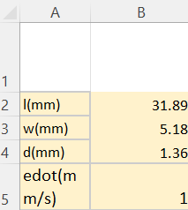
- For experimentally collected data
  - Input position (mm) and Load (N) into columns D and E respectively
  - Run the “Solver” add-on under the “Data” tab
    - Set Objective: $B$11
    - To: Min
    - By Changing Variable Cells: $B$12, $B$13, $B$14, $B$15
    - For Dobrynin Model
      - Subject to the constraints: $B$14 >= 1e-8
  - Allow solver to converge to the solution
  - Insert line graph with x axis lambda (column H, highlighted in gray) and data sets sigma exp (kPa) (column I, highlighted in green) and sigma model (kPa) (column R, highlighted in green)
  - The resulting graph shows visual conformation of the fit
    - If the model does not fit well use solver again
  - The results of cells B12-B15 (highlighted in orange) are the extracted parameters of the material
- For data from the literature
  - Input strain (epsilon) and stress (sigma exp kPa) into columns G and I respectively
  - Follow instructions b-f for fitting the model to the stress-strain curve

Screenshots
Before solver optimization
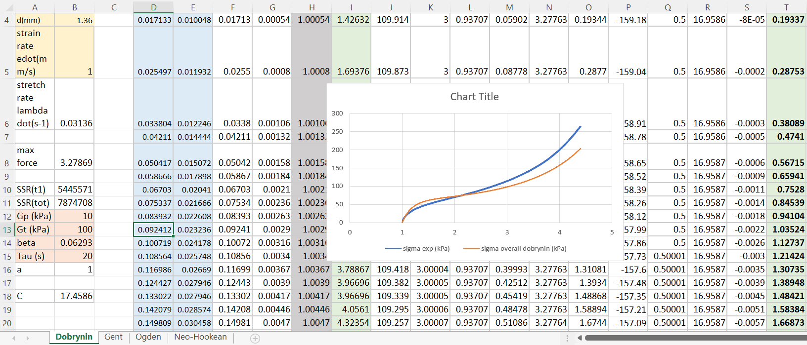
After solver optimization
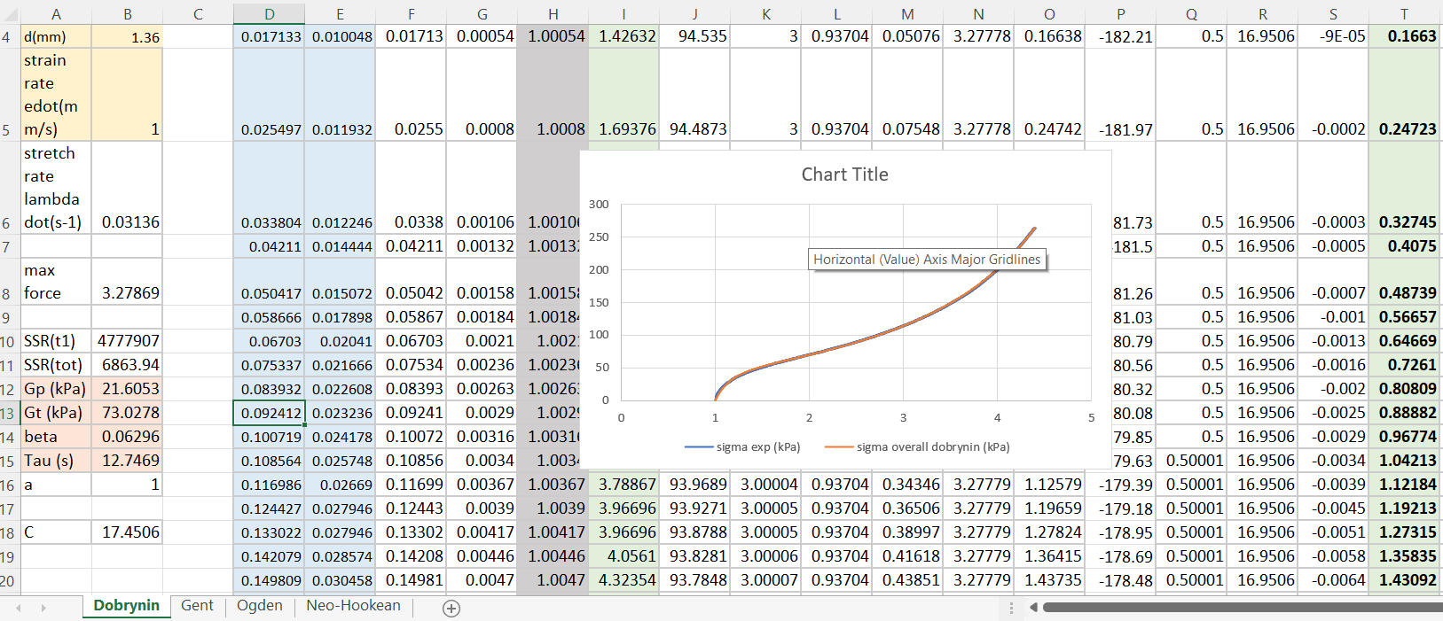

Reference
(1) Sheiko, S. S.; Dobrynin, A. V. Architectural Code for Rubber Elasticity: From Supersoft to Superfirm Materials. Macromolecules 2019, 52 (20), 7531–7546. https://doi.org/10.1021/acs.macromol.9b01127.

