# Using the Konkolewicz Group SEC Mark-Houwink-Sakurada Correction Spreadsheet

By Dominik Konkolewicz

**How to use the Mn, Mw and D (Mw/Mn) spreadsheet**

The spreadsheet can transform apparent number averaged molecular weight (Mn), weight averaged molecular weight (Mw) and dispersity (Mw/Mn) from apparent molecular weights obtained from either poly(methyl methacrylate) (PMMA) or poly(styrene) (Psty) standards to the molecular weights of the polymers:

* Poly(methyl acrylate) (PMA)
* Poly(ethyl acrylate) (PEA)
* Poly(n-butyl acrylate) (PBA)
* Poly(tert-butyl acrylate) (PtBA)
* Poly(ethylhexyl acrylate) (PEHA)
* Poly(ethyl methacrylate) (PEMA)
* Poly(n-butyl methacrylate) (PBMA)
* Poly(tert-butyl methacrylate) (PtBMA)
* Poly(benzyl methacrylate) (PBzMA)
* Poly(vinyl acetate) (PVA)
* Poly(oligoethylene glycol methyl ether methacylate) (POEOMA)
* Poly(N-isopropylacrylamide) (PNiPAm)

1. **Obtain apparent Mn and Dispersity for your polymer. Apparent here refers to the molecular weight of the equivalent PMMA or PSty calibrant.**
2. **Click on the tab with your relevant calibrant, either PMMA or PSty**
3. **Enter the apparent Mn and Mw/Mn value for the sample in the green cells. Make sure you are on the tab with your calibratant** **s (either PMMA or PSty)**

In the example below it would be 12000 Mn and dispersity of 1.25 as the apparent molecular weight based off of PMMA standards.

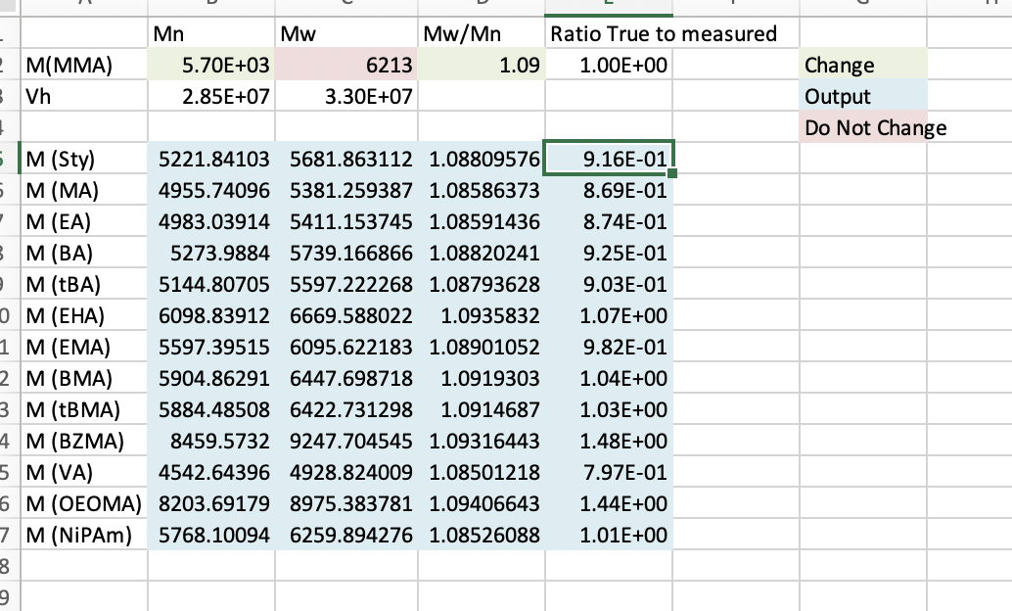

1. **Read off the corrected Mn, Mw and Mw/Mn for your polymer of interest**

For instance a polyBA corrected Mn would be 10946, corrected Mw would be 13624 and corrected dispersity would be 1.244

**How to use the MWD mark houwink correction spreadsheet**

The spreadsheet can transform a single apparent molecular weight distribution (MWD) to a the corrected monomer from either poly(methyl methacrylate) (PMMA) or poly(styrene) (Psty) standards to the molecular weights of the polymers:

* Poly(methyl acrylate) (PMA)
* Poly(ethyl acrylate) (PEA)
* Poly(n-butyl acrylate) (PBA)
* Poly(tert-butyl acrylate) (PtBA)
* Poly(ethylhexyl acrylate) (PEHA)
* Poly(ethyl methacrylate) (PEMA)
* Poly(n-butyl methacrylate) (PBMA)
* Poly(tert-butyl methacrylate) (PtBMA)
* Poly(benzyl methacrylate) (PBzMA)
* Poly(vinyl acetate) (PVA)
* Poly(oligoethylene glycol methyl ether methacylate) (POEOMA)
* Poly(N-isopropylacrylamide) (PNiPAm)

1. First up go the parameters tab and pull the Mark Houwink Sakurada (MHS) K and a values for both your calibrant polymer (typically PMMA or PSty) to your sample polymer, say in this case PBA. Parameters are shown below.

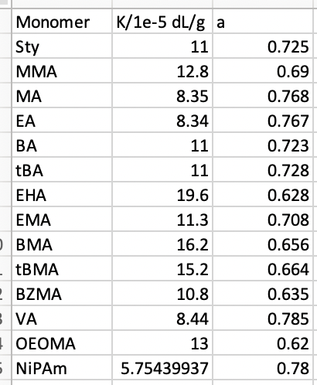

1. Put the relevant calibrant and sample MHS parameters in the top left columns:

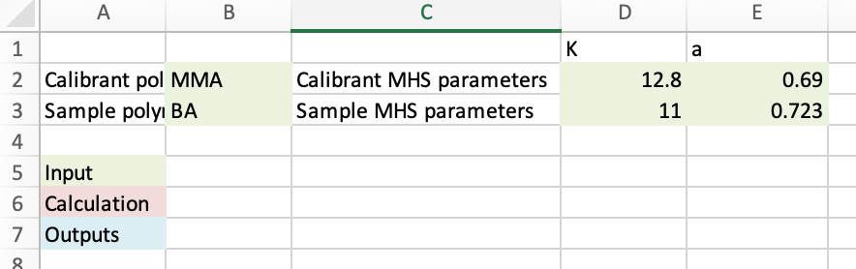

1. Clear the old dataset: select and delete cells **H6:N6** to bottom. (shortcut: select cell **H6** > press ctrl+shift+right > press ctrl+shift+down > press delete.)
2. Enter the column of log molecular weight values from your GPC/SEC analysis starting from Cell **H2**. You can expect about 100-1000 entries. If you only have the M values, not their log 10, you should first take the log10 of each M value.
3. Into column **I**, enter the column on either the trace/signal of MWD values corresponding to the M values in column **H**. This way the entry **I2** should be the distribution or signal of the log molecular weight in cell **H2**, **I3** should be the signal at log molecular weight in **H3**, etc.
4. Extend the equations to the new dataset: select **J5:N5** and double-click the bottom right corner of the marquee.

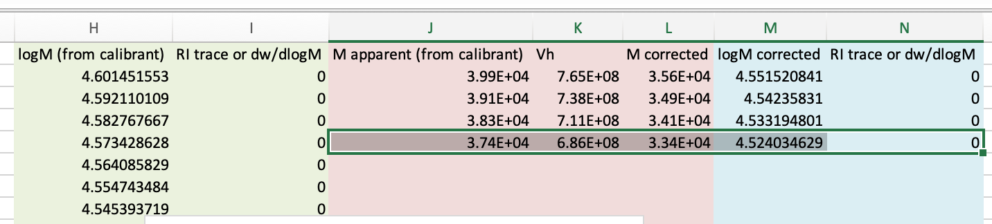

1. You should now have a fully corrected MWD. Blue is uncorrected, red is corrected.

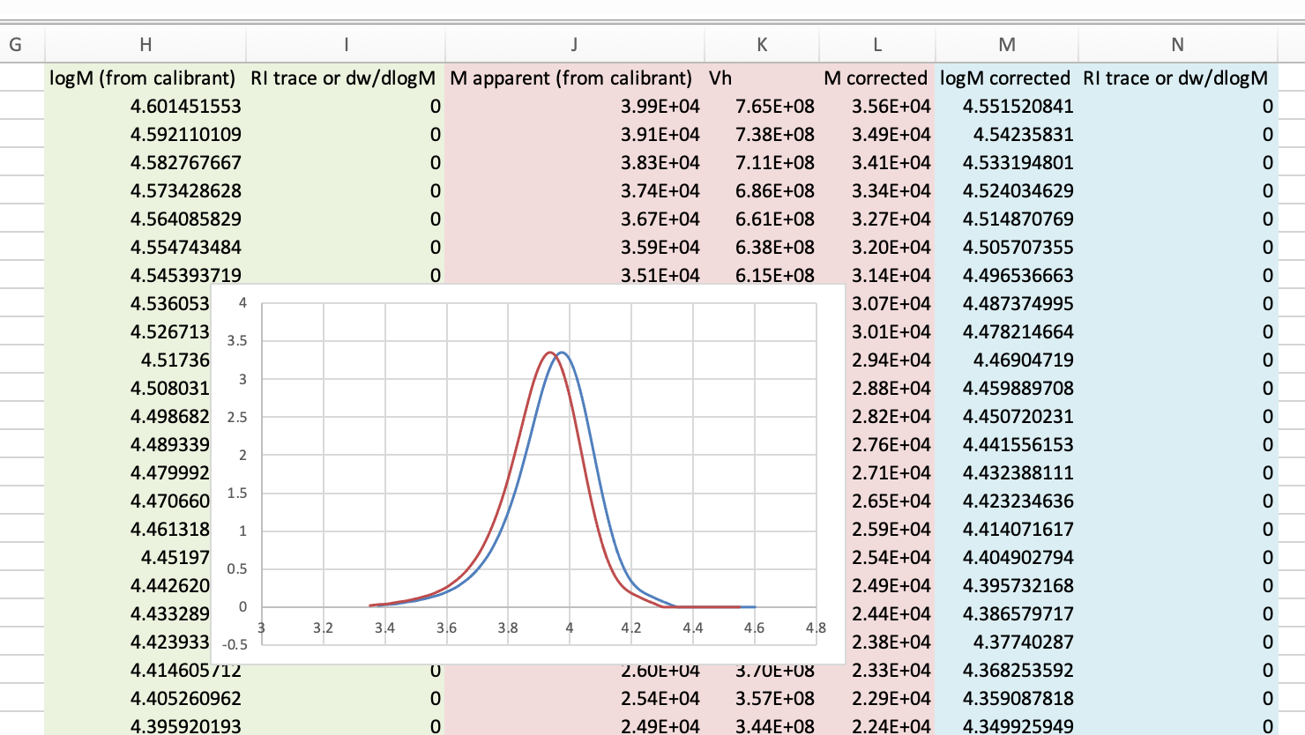

1. You are now be able to extract the corrected MWD from columns **M (corrected logM)** and **N (corrected RI signal/ MWD trace/ dwdLogM)**.