# Using the Estimator for the Rheological Molar Mass Between Crosslinks

By Dominik Konkolewicz and Amber M Hubbard

These instructions will cover how to use the Estimator for the Rheological Molar Mass between Crosslinks (Mc). This spreadsheet assumes you have reached a rubbery plateau as determined by either dynamic mechanical analysis (DMA) or rheology. This would indicate an essentially flat modulus as the frequency is decreased in a frequency sweep. It could also be applied to temperature sweep data, where the rubbery plateau is conventionally taken to be the modulus value at 50 °C above the glass transition temperature (*Tg*), or close to that value. These data can be obtained several ways. Frequency sweep experiments can be performed at or near a temperature 50 °C above the Tg, allowing the low frequency region (where E’ or G’ is essentially flat) to be used. Alternatively temperature sweep data can be used, allowing selection of Tg+50 °C to be used as the input E’ or G’ along with the associated temperature.

There are several versions of the estimator, depending on whether the experiment is run in shear (rheometer, giving G’) or tension (DMA, giving E’). The spreadsheet assumes incompressibility, hence

E’=3G’

Beyond the mode of the experiment (tension or shear) the final question to be answered is if the primary chain molar mass (Mp) is known. If the primary chain molar mass is known, (e.g., from size exclusion chromatography, with a post polymerization crosslinking approach), then the “…Mp is Known” tab should be chosen. If the Mp is unknown, then the “…Mp is Unknown” tab should be chosen. If experiments are performed in tension choose the “Elastic Modulus…” tab, if experiments are performed in shear choose the “Shear Modulus…” tab. All four tab options can be seen in the figure below.



As a first example, we will consider an experiment performed in tension at 60 °C. Input parameters are in green including absolute temperature (323 K in this case), plateau rubbery elastic modulus (1.5e6 Pa in this case) and material bulk density (g/mL). If unknown, a density of 1 g/mL (as was done here) can be used and is close to typical for many polymers. These are given in **Green**. Entries in **Red** should not be changed, as they consist of known constants and unit conversions. Molar mass between crosslinks is given (B11 in **Blue)** as ~5400 g/mol.

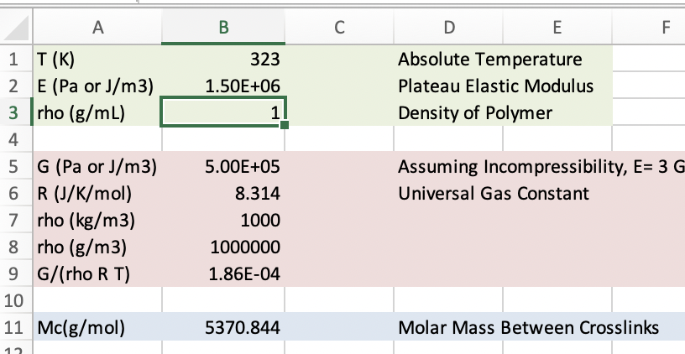

As a second example, we will consider a system done in shear at 30 °C with a known molar mass of 10,000 g/mol between crosslinks. Input parameters are in green including absolute temperature (303 K in this case), plateau rubbery shear modulus (8e5 Pa in this case) and material bulk density (g/mL). If unknown a density of 1 g/mL (as was done here) can be used and is close to typical for many polymers. B4 contains the molar mass of primary chains. These are given in **Green**. Again, entries in **Red** should not be changed, as they consist of known constants and unit conversions. Molar Mass between crosslinks is given (B11 in **Blue**) as ~1900 g/mol.

