# Using the Konkolewicz Group MATLAB code for Optimizing an Experimental Distribution Using the Model for Ideal Living Chain Distribution

These instructions will cover how to run the code in MATLAB including entering and an experimental distribution from a spreadsheet package such as excel or numbers. The distribution is assumed to come from size exclusion chromatography. A similar approach could be applied to distributions obtained by other analytical methods such as mass spectrometry.

Before running the code, it is important to convert the experimental distribution to be the GPC distribution (wlogM) vs chain length or degree of polymerization.

1. **Download all files to a single folder on your hard drive. Open this folder in MATLAB**

You should have all these files

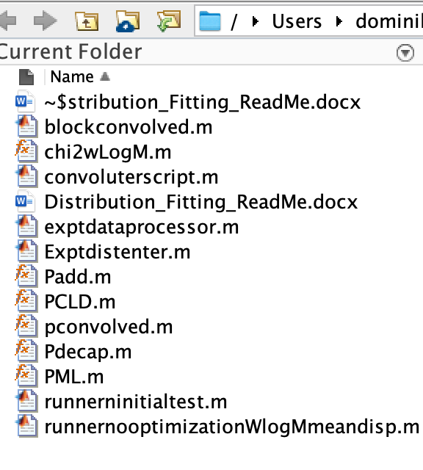

**B. Open and Run the file “Exptdistenter.m”**

Open the variable DPe (by double clicking it)

Copy the chain lengths from your experimental distribution as a column from your spreadsheet package and paste into DPe

Open the variable wLogMe (by double clicking it)

Copy the distribution signals (RI trace or similar) from your experimental distribution as a column from your spreadsheet package and paste into wLogMe

**C. Open the file “exptdataprocessor.m”**

This file corrects for possible overlapping data points and inserts experimental parameters such as

Monomer concentration (M0)

Chain length (RX)

Deactivator concentration (D)

Also inserts experimental mean chain length

Experimental dispersity

This is shown below

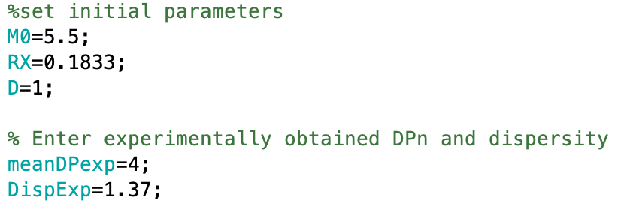

**Run the file “exptdataprocessor.m”**

**D. Open the file “runnerninitialtest.m” and use this to estimate initial values of k* and μdecap.**

**Initial estimates are inserted on lines 14 and 15. Recommended to start low in both k* and μdecap.**

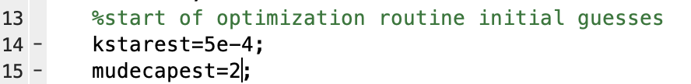

Run the file and observe the similarity between the experimental (blue) and modelled (red) distribution.

* If distribution looks too narrow, increase kstarest and decrease mudecapest.
* If distribution looks too broad decrease kstarest and increase mudecapest.
* To move distribution to the right, increase either kstarest or mudecapest.

The match between experimental model does not have to be ideal but needs to be in the ballpark.

**E. Open the file “runnernooptimizationWlogMmeandisp.m” and use this to optimize values of k* and μdecap and obtain fit.**

Use the estimated values obtained in step D and enter onto line 14 and 15 of code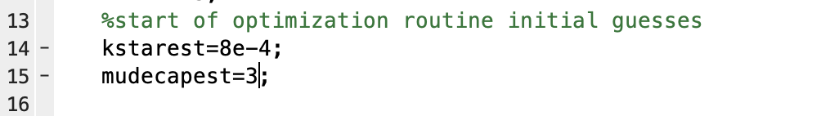

Run the code to obtain estimated fit. This could take minutes to hours. Result should be plotted and should show good agreement between experiment and model.

Values of optimized k*, μdecap, mean chain length, dispersity are determined and printed in command window.

Predicted model molecular weight distribution is determined.

The chain lengths can be found in the variable DPs

The distribution heights are given in the variable wLogMth

These variables can be opened by double clicking and copied to a spreadsheet program such as excel or numbers

If convergence is not obtained, increase 'TolFun'On line 25